

Child Friendly
Safeguarding Policy

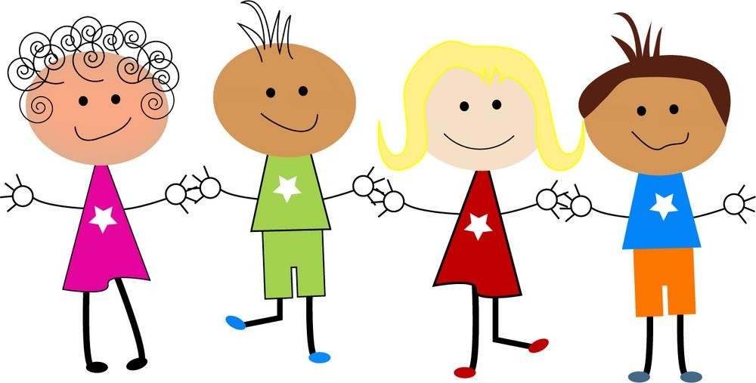
We think it is important for you to know where to get help.

If you need to talk, we will listen.
Autumn 2025
Our school has a Safeguarding Policy Statement and a Child Protection Policy.
These policies are for you, your parents, staff and governors.

This booklet is designed for you, so that you can better understanding about safeguarding.

We created this booklet to help you decide what could be a ‘problem’ and where to get help and support.

There may be times when you want to talk to someone in school about a problem that might be upsetting you. This might be about
friendships, something that is happening at home or in school.

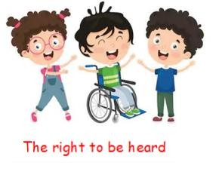
We have people in school who are able to help you. It is
important that you know where to get help if you are worried or unhappy about something.
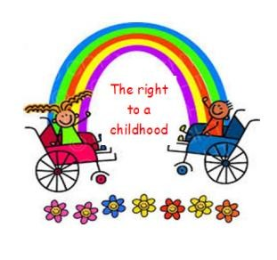
Safeguarding means that all staff will:
Help you when you are upset. Help protect you from harm.
Help make sure you are safely looked after.
Help make sure you have the best life chances.

Who can help you in school?
Everyone!
Teachers
Other adults in the classroom
Other adults in the school
Adults in the office
Adults on the Catering Team

All of the adults think that your health, safety and wellbeing are very important. We respect you and want to keep you safe.
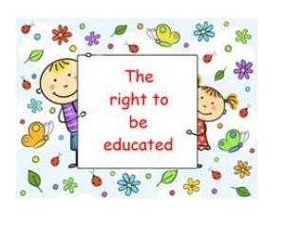
We teach you how to recognise risks and how to stay safe.

There are adults in the school who wear red lanyards with their ID badges on. These adults have extra training to help you:

Mr. Davie- Head of School
Miss Barlow – Deputy Head teacher
Mrs. Cory – Assistant Head teacher – Inclusion
Mrs Salador – Assistant Head teacher – UKS2
Mr. Lake – Assistant Head teacher – KS1
Mrs. Tiffin – Assistant Head teacher – EYFS
We try to provide a safe environment for you to learn in.

We want to make sure you remain safe, at home as well as in school.
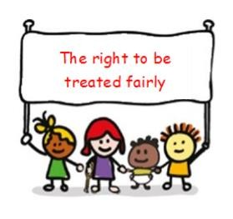
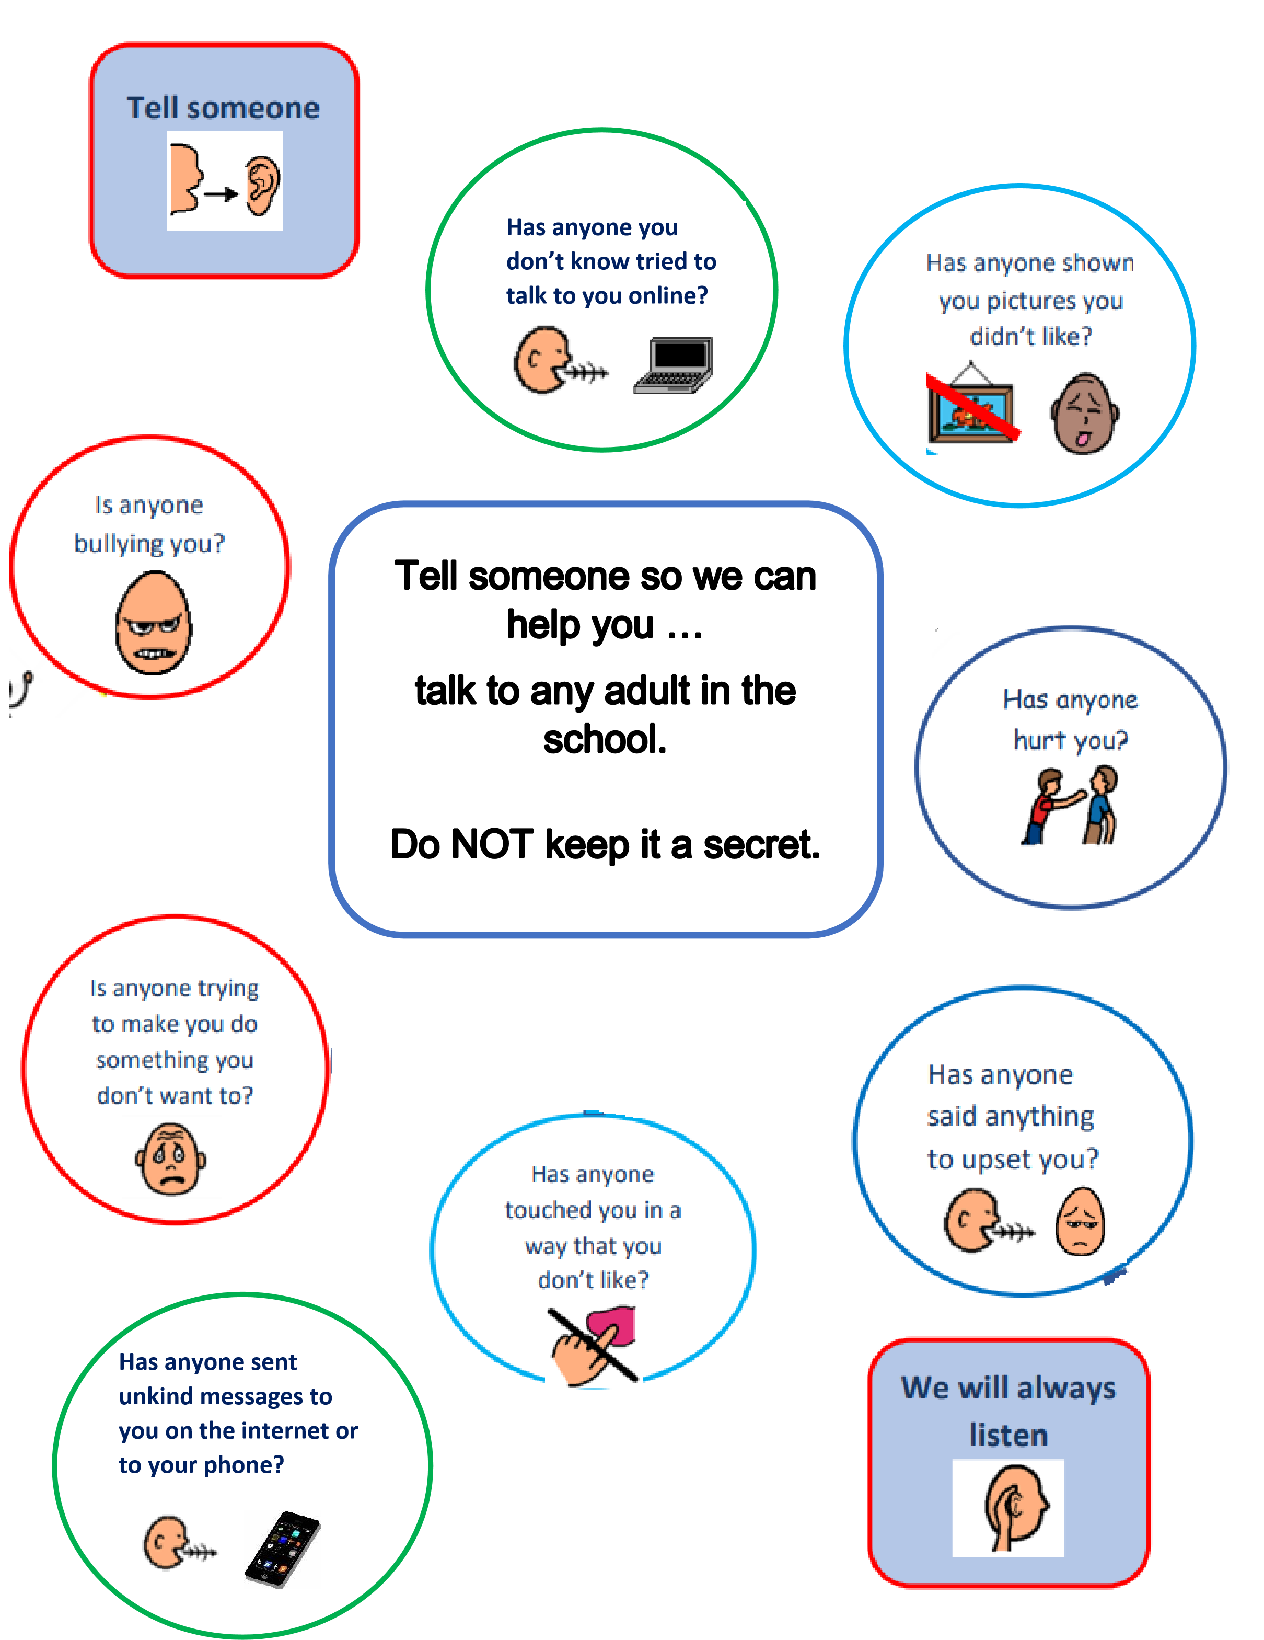

Other places that may be able to help you:


