Cherry Tree Primary School and Nursery

Honesty, Ambition, Respect, Kindness.



Relationships and Behaviour Policy

Updated: September 2026
Ratified by Governors September XXX
To be reviewed: September 2027

DRAFT

At Cherry Tree, we have 3 simple rules to ensure our behaviour is positive:
- Be ready
- Be respectful
- Be safe
These rules encompass many expectations.
At Cherry Tree, we use a therapeutic approach to managing behaviour to ultimately create an environment that is warm and understanding.
A therapeutic approach is defined as an approach to behaviour that prioritises the pro-social experiences and feelings of everyone within the dynamic.
Aims:
- To teach children how to become internally disciplined (making the right choices/managing antisocial emotions) and intrinsically motivated
- Promote and prioritise pro-social feelings and experiences
- Ensure that all children are given the necessary support to achieve
- Roles and Responsibilities
All Pupils Will:
- Contribute to a positive school environment.
- Take responsibility for their actions and be honest.
- Understand the behaviour support and sanction systems.
- Expect fair, reasonable treatment.
- Have access to a safe and confidential space to discuss concerns.
All Staff Will:
- Follow the behaviour policy and procedures.
- Recognise that every child is their responsibility and are accountable for their behaviour.
- Model respectful behaviour towards colleagues, parents, and pupils.
- Embed the training from TPP and attachment awareness
- Promote positive reinforcement
- Seek support from the Headteacher, Deputy Headteachers, Assistant Headteachers, SEMH assistant or SENCo as needed.
- Ensure visitors uphold the school's behaviour standards.

SEMH assistants:
- Provide emotional and behavioural support to pupils.
- Work closely with staff, parents, and external agencies to promote well-being.
- Use CPOMS to log and monitor behaviour concerns.
- Embed Trauma Perceptive Practice (TPP) in behavior management and attachment awareness training
- Promote positive reinforcement
SENCo Responsibilities:
- Integrate behaviour targets into One Plans.
- Develop and monitor Consistent Management Plans (CMPs) for pupils with significant behaviour challenges.
- Liaise with parents and external agencies for additional support.
Senior Leaders AHTs:
- Oversee the daily implementation of the behaviour policy in their phase
- Support staff with behaviour strategies.
- Ensure pupils, staff, and parents' needs are met.
- Allocate resources for effective policy execution.
Deputy Headteacher:
- Oversee the daily implementation of the behaviour policy across all phases.
- Support staff with behaviour strategies.
- Ensure pupils, staff, and parents' needs are met.
- Ensure the behaviour curriculum is delivered effectively
- Allocate resources for effective policy execution.
Headteacher Responsibilities:
- Oversee the daily implementation of the behaviour policy.
- Support staff with behaviour strategies.
- Ensure pupils, staff, and parents' needs are met.
- Allocate resources for effective policy execution.
- Report to the governing body and review the policy annually.

Types of behaviour:
Pro-social behaviour is defined as:
Behaviour that is positive, helpful and intended to promote social acceptance. It is characterised by a concern for the rights, feelings and welfare of other people.
Anti-social difficult behaviour is defined as:
Behaviour that violates the rights of another person
Behaviour that is anti-social, but not dangerous
Anti-social dangerous behaviour is defined as:
Behaviour which will imminently result in injury to self or others, damage to property or behaviour that would be considered criminal if the person was the age of criminal responsibility, such as racist abuse.
Behaviour that causes harm or injury to an individual, the community or to the environment

Positive Reinforcement & Recognition
To support positive behaviour, we recognise and celebrate where children have made good efforts to follow our rules and values.

We will:
- Catch them being good
- Be relentlessly positive!
- Keep the positive visible to all and the negative hidden from most.
- Children can still receive praise later after an incident or consequence earlier
- Meet and greet all children and ensure you make positive contact with all children throughout the day
- Reward for behaviour that goes ‘over and above’ the expected, through assemblies or in class
- Use a message home for a positive reason (call, note) or tell another adult about a child’s achievement, who can later tell the child
- Celebration assembly- celebrate school rules, attendance, behaviour, work etc
- Praise children for demonstrating the values and rules.
- Involve parents and carers by sharing positive moments and successes.

Supporting Behaviour
We believe that promoting good behaviour is a partnership between school, pupils, and families.
We will:
- Keep parents and carers informed about their child’s achievements.
- Encourage open communication between home and school.
- Work together to ensure all children feel valued and motivated.

Behaviour curriculum
As part of creating the empowering culture, we teach children the expected behaviours.
Examples of pro-social behaviours we might expect to see:
Be Ready | Be Respectful | Be Safe
Have the correct uniform  Have equipment ready  Be in school on time  Complete homework | Say please and thank you  Hold doors open for others  Talk kindly and say kind things Say good morning / afternoon to adults  Respect others’ right to learn  Look after school property  Use a clam and polite voice  Value differences  Follow instructions  Tidy up any mess you make | Sit sensibly in your chair  Walk in the corridor  Kind hands towards others  No hurting others  Follow instructions

Typically, these are taught at the beginning of the year, when class rules are established and school rules are recovered. Throughout the year, through assemblies and adult reminders, children are taught about our core, expected behaviours. Our PSHE curriculum also reinforces these. In the topic
‘relationships’, children learn about being respectful. This is later reinforced through our topic ‘celebrating difference’. Safety is taught throughout the curriculum in a range of subjects, from science to DT. Additional experiences all add to the pupil’s knowledge of how to keep safe (e.g. our
Outdoor Play teaches about risk assessing, Crucial Crew teaches about topical issues).
Examples of anti-social behaviours:
Behaviour | Typical response
Running in the corridor | “Walking in the corridor, thank you”
Climbing on top of cupboards | Use of de-escalation script
Screaming and shouting | Use of de-escalation script
Swearing at others | “NAME, we use kind words in this school thank you” followed by reflection
Pushing, punching or kicking others | Use of de-escalation script, use of steering or guiding, followed by logical consequences
Rough play | “NAME, safe play thank you”.
Refusing instructions/direction from an adult | De-escalation script.  Follow up with logical consequence when regulated.
Refusing to work | Seek to understand the reason for refusal (need). Reminder that work needs to be completed - look for ways to support.

Where anti-social behaviour occur, staff will promote the behaviour they need and expect to see and then seek to discover an explanation or solution for the behaviour.
Sometimes it will be clear that a child is becoming increasingly distressed. Their body language will change, they may not be making eye contact and their communication will have changed. We still need to display that we recognise them and their struggle. We use the following to prevent further escalation:
Body language – open and committed
Reconnecting through a smile, physical contact or acknowledgement
We use ‘limited choices’ to achieve our desired outcome. For example, if we want a child to put a toy down, we would say. “You can put the toy in your pocket or in your tray, it’s up to you, it’s your choice.”
We use a simple de-escalation script to support pupils who are showing dysregulation:
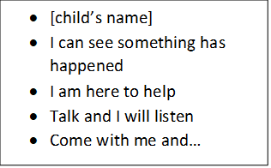
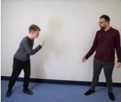
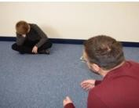
We also use de-escalation body language:

• | Outside of an outstretched arm
• | Good distance
• | Standing to the side
• | Relaxed hands
• | Managing height

Following the above, if there is a need for further action, this would take the form of a logical consequence.

Caring and resolving incidents
In order to show that we care, we use a therapeutic approach to managing behaviour. The emphasis is placed on the child’s feelings and the root of the problem. Any consequences are as a direct result of a child’s choices and are fair and consistent. Adults do not respond emotionally to poor behaviour, instead sticking to the scripts and planned responses outlined below.
If a child displays difficult behaviour, we will use the following steps.
- Private reminder of the behaviour expected (listening, thank you)
- Private caution (e.g. focus on your work, thank you, listen when someone is speaking, thank you)
- Last chance with reminder script
- Time out – away from the situation (this will result in time owed time at break/lunch for a brief restorative meeting)
- Restorative meeting at break/lunch

If the behaviour persists / escalates (in class)
Where dangerous behaviour is seen or difficult behaviour persists, adults will issue a consequence.
- Sent to partner year group teacher – time out with a year group partner if they need to reset and provide some respite for other pupils (no more than 5 minutes)
- Sent to assistant head teacher – if difficult behaviour persists, and the steps within the policy have been taken, the child will be sent to work in a different classroom with the assistant headteacher for the rest of the lesson.
- Session out – internal suspension – if the child refuses to work in a different class or difficult behaviour still persists, they will be removed for the entire session (morning or afternoon). They will work in a separate room with a member of the inclusion team, where they will complete work and hold a restorative meeting. Parents will need to be informed.
Behaviour incidents that cause a concern must be logged on CPOMS under “behaviour log”.

Reflection room (break/lunch time)
During lunchtime, there is a reflection room. Children will be sent here if they use physical behaviour or inappropriate language. KS2 children will spend the entire lunch in reflection, including eating. There is an outdoor space to play in. A restorative behaviour form must be filled out by the child – see appendix 3. The adult on duty will fill out a reflection form. A copy of this will be kept in a file for reference if needed. A record of the incident and action taken must be recorded on CPOMS and parents can be informed. During Reflection time, children may work on “educational development” around the issues that have caused the antisocial behaviour. Alternatively, for repeated behaviour of the same nature, a separate intervention(s) may be carried out to support this educational development.
Consequences.
We use consequences, not punishments. This is something that logically follows from an action. This should relate directly to the action itself. We can start with the words ‘obviously…’ or ‘clearly…’ e.g if a child throws a pencil, obviously they need to pick it up. If a child swears, clearly they need to apologise and sit with an adult to discuss the importance of respect. Examples can be found in appendix 4.
The initial consequence should be related to the primary action, not the secondary actions that follow. These should be addressed in the restorative meeting and appropriate consequences issued here.
These are either protective or educational.
Protective consequences:
- Removal of a freedom to manage harm:
e.g. Increased staff ratio, limited access to outside space, escorted in social situations, no availability of minibus/car, differentiated teaching space, exclusion from the classroom or school
Educational consequences:
- The learning, rehearsing or teaching so the freedom can be returned
e.g. Completing tasks, rehearsing, assisting with repairs, educational opportunities, research, conversation and exploration.
Only members of SLT or inclusion can issue the protective consequence isolation from an entire lesson or internal exclusion.

Restorative meetings
Following an incident, the child attends a restorative meeting with an adult to revisit the incident and repair the damage done, exploring the feelings and emotions that led to this. The length and depth of the meeting will depend on the severity of the incident.
5 questions to support the restorative meeting.
• | What happened?
• | What were the people involved feeling?
• | Who has been affected and how?
• | How can we put it right?
• | What can we do differently next time/what choice could we make?

Some children may respond better to this meeting if it was delivered through a different medium, for example: a social story, comic strip, Lego therapy or through pictures.
If difficult or dangerous behaviour persists, then SLT and/or inclusion will identify the cause of the problem and put a behaviour plan in place (therapeutic tree/predict, prevent and progress/ therapeutic plan).
All staff are consistent with their approach to ensure children know what the outcome of their behaviour is, because this is how we do things here at Cherry Tree .

Recording
We use CPOMS to record ‘notable incidents’. We define notable as any of the following:
- Bullying
- Child on child abuse (online)
- Child on child abuse (physical)
- Child on child (verbal)
- Criminal offence
- Damage to property
- Harm from absconding
- Harm to staff (physical)
- Harm to staff (verbal)
- Persistently disruptive to learning or school
- Prejudice or racist incidents
We also log racist behaviour or behaviour that could be considered “hateful” or “discriminatory” e.g. homophobic, exist or relating to disability, prejudice or racist (or other protected characteristics).
We log and investigate behaviour that is deemed or reported to be bullying. Please see Anti-bullying policy.
This policy works alongside:
- Exclusion policy
- SEN policy
- Reasonable force policy
- Anti-bullying policy

Safeguarding
Where a circumstance arises that endangers the safety of a pupil or staff member, the school will act swiftly and decisively to remove the threat and reduce the likelihood of its reoccurrence. This will be done through the most appropriate action from the following list:

- Removal of freedom (playtime)
- Individual risk assessments
- Contacting outside agencies (e.g. Children and families’ support hub, SEMH panel, school inclusion partner, education psychologist, police, community support action groups)
- Removed from class as an internal exclusion (for a session or a number of sessions) in order to educate the child in appropriate behaviours
- Internal suspension
- Suspension (fixed period)
- Exclusion
- Following dangerous behaviours, a risk assessment may be drawn up for the child. This will include strategies to prevent and respond to potential dangerous incidents in the future.

Behaviour plans
We use a variety of behaviour plans in accordance to the graduated response tiered system (see Appendix 1). These plans include strategies to prevent the likelihood of further escalation or reoccurrence of the anti-social behaviours. They also aim to be proactive in supporting the child to manage their behaviours to ensure they make progress in reducing the amount of incidents.
Some of the reasonable adjustments we might make, and strategies we might use, are listed below:
- Planned brain breaks (e.g through a report card, reward chart, in-class job, sensory box)
- Educational interventions (expected behaviours, emotional regulation, social stories etc)
- Time-out opportunities when feeling dysregulated
- Adaptations to work
- Home communication book

Suspension and permanent exclusion
All pupils are entitled to an education where they are protected from disruption and can learn in a calm, safe and supportive environment. At Cherry Tree Primary School, we use suspension and permanent exclusion in response to serious incidents or in response to persistent poor behaviour which has not improved following in school support and intervention.
The circumstances that may warrant a suspension or permanent exclusion to occur can be found within the ‘Suspension and Permanent Exclusion from maintained schools, academies and pupil referral units in England including pupil movement guidance’.
Permanent exclusion
A permanent exclusion is when a pupil is no longer allowed to attend a school (unless the pupil is reinstated). The decision to exclude a pupil permanently should only be taken:
- in response to a serious breach or persistent breaches of the school's behaviour policy; and
- where allowing the pupil to remain in school would seriously harm the education or welfare of the pupil or others such as staff or pupils in the school
Reasons for a permanent exclusion may include:
Physical assault against a pupil
- Physical assault against an adult
- Verbal abuse or threatening behaviour against a pupil
- Verbal abuse or threatening behaviour against an adult
- Use, or threat of use, of an offensive weapon or prohibited item that has been prohibited by a school’s behaviour policy
- Bullying
- Racist abuse
- Abuse against sexual orientation or gender reassignment
- Abuse relating to disability
This is not an exhaustive list. We follow the guidance in The DfE’s “Suspension and Permanent Exclusion from maintained schools, academies and pupil referral units in England, including pupil movement”.

Child on child abuse
Our school recognises that some children may abuse their peers and that this may happen in school, or outside of it. Any incidents of child on child abuse will be managed in the same way as any other child protection concern and we will follow the same procedures. We will seek advice and support from other agencies as necessary and ensure that appropriate agencies are involved when required. Our school understands that even though child on child abuse / harmful sexual abuse may not be reported, it is likely that it is occurring and we are clear there is a zero tolerance approach to inappropriate or abusive behaviour.

Searching
We follow the DFE’s Searching, Screening and Confiscation advice for schools (July 2022). The headteacher and authorised staff have a statutory power to search a pupil or their possessions where they have reasonable grounds to suspect that the pupil may have a prohibited item listed below. At Cherry Tree Primary School, the authorised staff are the Deputy Designated Safeguarding Leads.
The list of prohibited items is:
- knives and weapons
- alcohol
- illegal drugs
- stolen items
- Any article that the member of staff reasonably suspects has been, or is likely to be used:
- to commit an offence, or
- to cause personal injury to, or damage to property of; any person (including the pupil)
- tobacco and cigarette papers;
- fireworks; and
- pornographic images
- mobile phones (during the school day)

Staff training
All staff undergo induction training which includes understanding the school’s behaviour policy. In addition, they receive regular behaviour training and bespoke training where necessary.

Appendix 1. Behaviour planning tools

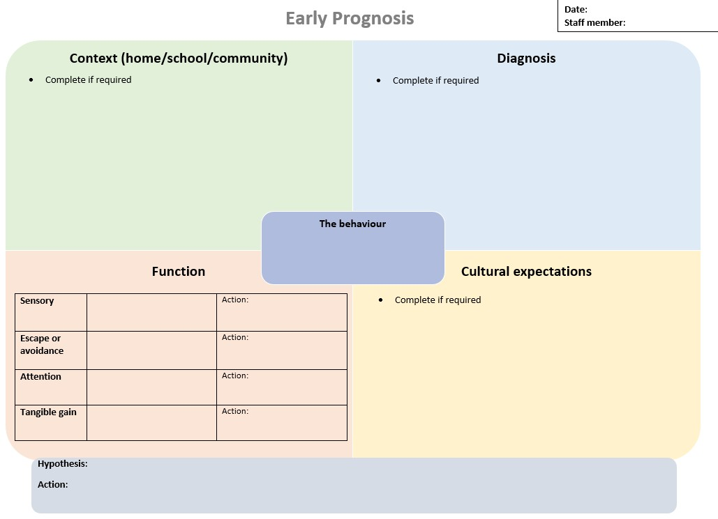
Conscious Behaviour Checklist
Question | Response
What is their desired outcome from their behaviour?
What is the motivation to behave antisocially?
What is the motivation to behave prosocially?
What are the expected consequences?
(Limits to freedom)
How can I impact on the child’s beliefs or values?

Subconscious Behaviour Checklist
Question | Response
Is the behaviour medical?

Is the behaviour habitual?
What is causing the fear?
(topic, adult, time, activity, peers, transition, noise etc)
What is causing the anger? (topic, adult, time, activity, peers, transition, noise etc)
What is causing the confusion? (topic, adult, time, activity, peers, transition, noise etc)
What is causing the embarrassment? (topic, adult, time, activity, peers, transition, noise etc)
What is causing the anxiety? (topic, adult, time, activity, peers, transition, noise etc)
What is over stimulating or overwhelming them?
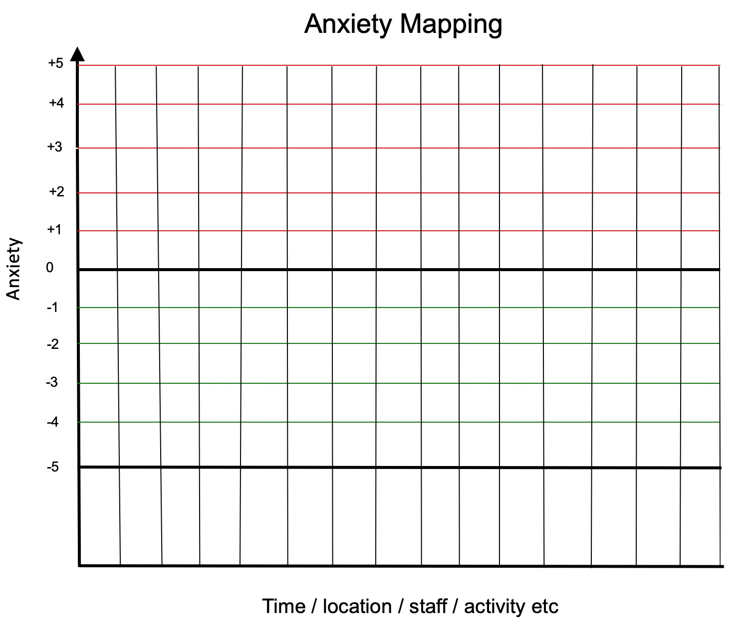

Predict, Prevent & Progress
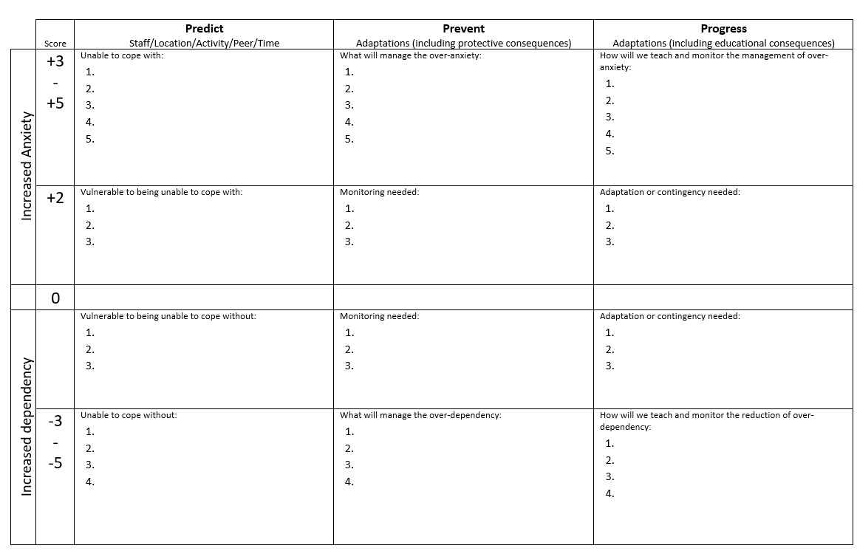

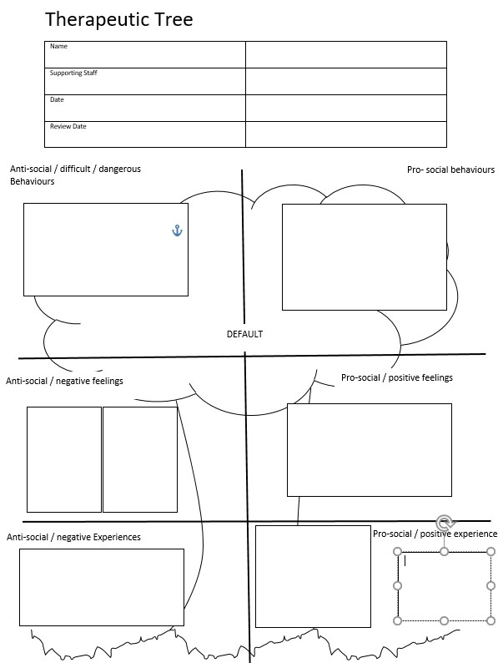

Therapeutic Plan

Name | DOB |  | Date | Review Date
Photo | Risk reduction measures and differentiated measures (to respond to triggers)
Pro social / positive behaviour |  | Strategies to respond
Anxiety / DIFFICULT behaviours |  | Strategies to respond
Crisis / DANGEROUS behaviours |  | Strategies to respond
Post incident recovery and debrief measures

Signature of Plan Co-ordinator………………………………… Date ……………….

Signature of Parent / Carer……………………………………… Date ………………

Signature of Young Person………………………………………Date……………….

Appendix 2.

Statement on the use of Physical Interventions

- There are occasions when staff will have cause to have physical contact with pupils for a variety of reasons, for example:

  - to comfort a pupil in distress (so long as this is appropriate to their age);
  - to gently direct a pupil;
  - for curricular reasons (for example in PE, Drama etc);
  - in an emergency to avert danger to the pupil or pupils;

- In all situations where physical contact between staff and pupils takes place, staff must consider the following:

  - the pupil’s age and level of understanding;
  - the pupil’s individual characteristics and history;
  - the location where the contact takes place (it should not take place in private without others present).

Within Cherry Tree school this means that as a member of staff may physically guide, touch or prompt children in appropriate ways at appropriate times. It is extremely important that you have read and understood all relevant policy to appreciate the reasons why we may choose to use physical intervention or restrictive physical intervention with children and the appropriate ways in which we do so.

Why Do We Use Touch?
We may choose to use a physical intervention with children for a variety of reasons, but in general terms we would normally do so for either comfort reward or guidance.

How Do We Use Touch?

Hugging
At Cherry Tree school, we encourage staff that are using touch for comfort or reward to use a ‘school hug’. This is a sideways on hug, with the adult putting their hands on the child’s shoulders. This discourages ‘front on’ cuddling and the adult’s hands on the shoulders limits the ability of the child to turn themselves into you.

Hugging can be used either standing or seated

Hand-Holding
We recognise that children sometimes enjoy being able to hold hands with adults around them. This is perfectly acceptable when the hand holding is compliant. However, if the handholding is being used by an adult as a method of control to move children, this can become a restraint. Therefore, we encourage the use of the ‘offering an arm’. This is done by the adult holding their arm out, and the child is encouraged to wrap their hand around the adult’s lower arm. The adult’s other hand can then be placed over the child’s for a little extra security if it is required.
In summary, it is generally deemed appropriate to touch others on the upper arm and shoulders.
Lap-Sitting
At our school we actively discourage lap-sitting. Children should be taught to seek
comfort/attention through other means, explored within Steps training. If a child attempts to sit on your lap, explain and ask them to sit next to you if it is appropriate.

At times, children may in such crisis or distress that they hold you in a way which is not described as above (e.g. ‘front on’ hug/lap sitting). If this should happen please ensure that you have informed a senior member of staff. You will be asked to make a note of this, this will be in order to record and monitor the amount of times the student is seeking this support from staff and to analyse the child’s unmet need.
Please note that although we have a touch policy and believe that contingent touch can be a positive experience for the children that we care for, this does not mean that you have to use physical interventions with children.

It should also be realised that some children will not want to be touched. Please respect this.
Staff have a ‘Duty of Care’ towards the students in their care. Therefore if a student is likely to be at risk from harm if you do not physically intervene in an emergency situation, you must take action. The action you take will be dependent on the dynamic risk assessment that you make at that moment in time.
We also have within our behaviour policy, a section on restrictive intervention in line with Essex Steps training.
Parents/carers will be made aware of this statement when their child is admitted to this school.
If you have any questions or would like a further discussion regarding this policy, please speak to your line manager at the earliest available opportunity.

Appendix 3. Reflection form
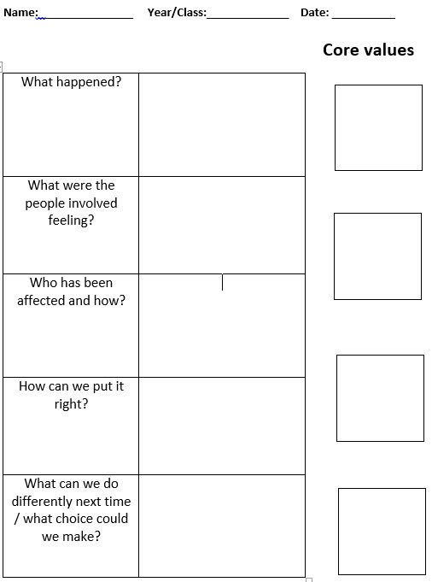
School rules:

Be Ready

Be Respectful

Be Safe

Appendix 4
Examples of likely scenarios with consequences

Action | Consequence
Dangerous behaviour in class | Isolation from the lesson until ready to return
Persistent dangerous behaviour at playtimes | Protective measure implemented (reflection room at lunchtime, adult support, reduce freedom by being assigned a specific area)
Throwing objects in class | Restorative conversation around dangers and respect and pick up objects
Throwing work on the floor or disrespecting property | Tidy up mess and restorative conversation around respect
Being unkind to others verbally | Restorative conversation around kindness and apology
Fighting | Reflection room at lunchtime to hold a restorative meeting with both parties and apologies
Persistently breaking school rules | Restorative conversation
Swearing | Restorative conversation around kind words
Refusing to work | Work to be completed

Appendix 5. Reasonable force
Guiding, Escorting and Supporting
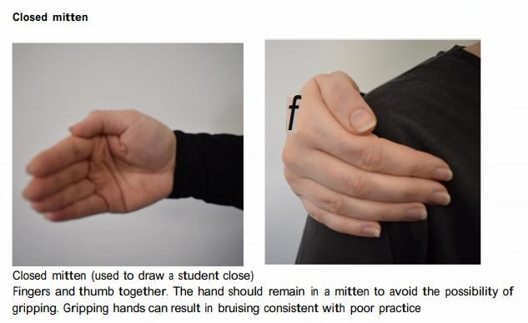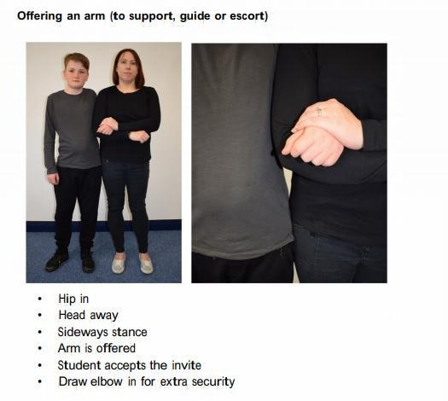

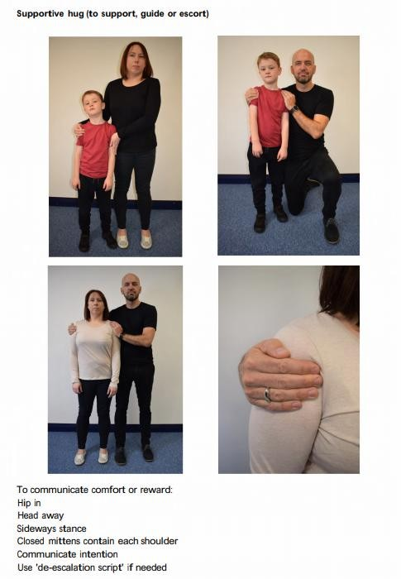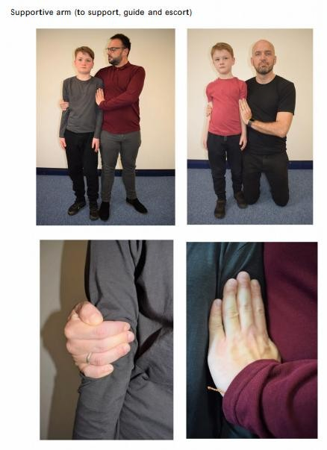

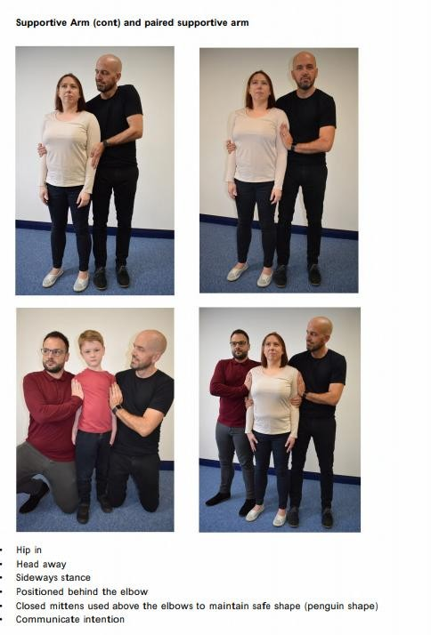

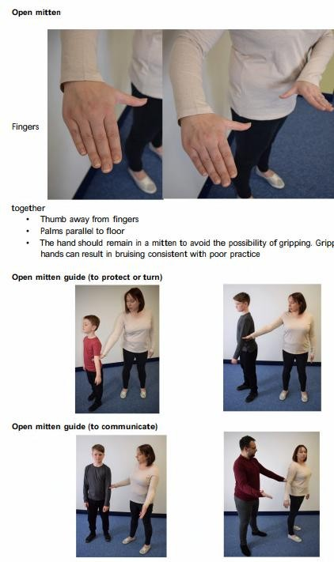

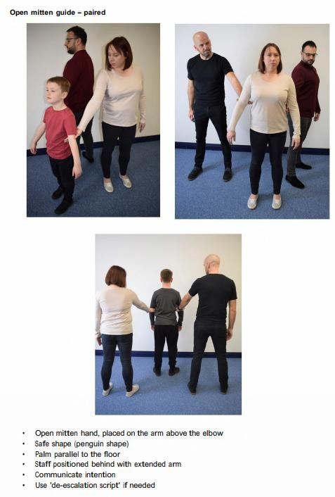

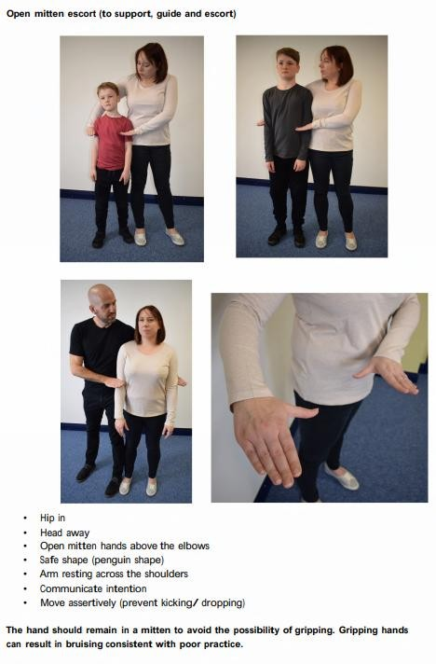

Appendix 6 – Graduated response


