Cherry Tree Primary School and Nursery

(A member of the Berlesduna Academy Trust)

Caring, Thriving, Preparing, Succeeding.



Personal, Social and Health Education Policy
(including Relationships and Sex Education)

Policy created using The Key model policy as a starting point. | July 2020
Policy circulated | July 2020
Policy ratified | Autumn 2020
Policy reviewed | Autumn 2022
Policy reviewed | Autumn 2023
Policy reviewed | Autumn 2024
Signed  Chair of Governors | Mrs S. West
Policy to be reviewed | Autumn 2025

Contents

- Aims ................................................................................................................................2

- Statutory requirements ....................................................................................................2

- Policy development .........................................................................................................3

- Definition .........................................................................................................................4

- Curriculum .......................................................................................................................4

- Delivery of Relationships and Health Education (including Sex Education) ....................5

- Roles and responsibilities ................................................................................................5

- Parents’ right to withdraw ................................................................................................6

- Training ........................................................................................................................... 6

- Monitoring arrangements ................................................................................................ 6

- Appendices
Appendix 1: Whole School Curriculum map.....................................................................7 Appendix 2: Curriculum Overview, by year group…………..............................................9
Appendix 3: Parent form: withdrawal from sex education within RSE............................13

Aims
The aims of relationships and health education (including sex education) at our school are to:
Provide a framework in which sensitive discussions can take place
Prepare pupils for puberty, and give them an understanding of sexual development and the importance of health and hygiene
Help pupils develop feelings of self-respect, confidence and empathy
Create a positive culture around issues of sexuality and relationships
Teach pupils the correct vocabulary to describe themselves and their bodies

These aims support our overall ethos: Caring, Thriving, Preparing, Succeeding.

Statutory requirements
As a primary academy school, we must provide Relationships and Health Education to all pupils, as per section 34 of the Children and Social work act 2017.
We do not have to follow the National Curriculum, but we are expected to offer all pupils a curriculum that is similar to the National Curriculum including requirements to teach science, which would include the elements of sex education contained in the science curriculum.
In teaching Relationships and Health Education, we are required by our funding agreements to have regard to guidance issued by the Secretary of State as outlined in section 403 of the Education Act 1996.
At Cherry Tree, we teach Relationships and Health Education (including sex education) as set out in this policy.

Policy development
This policy has been developed in consultation with staff, pupils and parents. The consultation and policy development process involved the following steps:
- Review – a member of staff or working group pulled together all relevant information including relevant national and local guidance.

- Staff and Governors consultation – all school staff and governors were given the opportunity to look at the policy and make recommendations.

- Pupil consultation – through Pupil Voice, we investigated what exactly pupils want from their Relationship and Health Education.

- Parent/stakeholder consultation – parents and any interested parties were invited to attend a meeting about the policy.

- Ratification – once amendments were made, the final policy was shared with governors and ratified.

Definition
Relationships and Health Education is about the emotional, social and cultural development of pupils, and involves learning about relationships, healthy lifestyles, diversity and personal identity.
Relationships and Health Education involves a combination of sharing information, and exploring issues and values.
Sex education is about developing understanding, from a scientific perspective, in order to enable safeguarding, not about the promotion of sexual activity.

Curriculum
Our curriculum is set out as per Appendix 1 but we may need to adapt it as and when necessary.
We have developed the curriculum in consultation with parents, pupils and staff, taking into account the age, needs and feelings of pupils. If pupils ask questions outside the scope of this policy, teachers will respond in an appropriate manner so they are fully informed and don’t seek answers online. They may also notify parents, if appropriate, so that relevant conversations can be had at home.
Relationships education focuses on teaching the fundamental building blocks and characteristics of positive relationships, including:
- Families and people who care for me;
- Caring friendships;
- Respectful relationships;
- Online relationships;
- Being safe.

Health education focuses on teaching the fundamental building blocks and characteristics of positive relationships, including:
- Mental wellbeing;
- Internet safety and harms;
- Physical health and fitness;
- Healthy eating;
- Drugs, alcohol and tobacco;
- Health and prevention;
- Basic First Aid;
- Changing adolescent body.

Sex education (Year 6 only) focuses on:
- Human reproduction (how a baby is made and how it grows).

These areas of learning are taught within the context of family life, taking care to ensure that there is no stigmatisation of children based on their home circumstances. Families can include single-parent families, LGBTQ+ parents, families headed by grandparents, adoptive parents, foster parents/carers amongst other structures along with reflecting sensitively that some children may have a different structure of support around them (for example: looked after children or young carers).

For more information about our curriculum, see Appendices 1 and 2.

Delivery of Relationships and Health Education (including sex education)
Relationships and health education is taught within the Personal, Social, Health and Economic (PSHE) education curriculum. Some biological aspects of health education (puberty) can be taught within the science curriculum, and other aspects can be included in religious education (RE).
Pupils also receive stand-alone sex education sessions in Year 6, delivered in class by their usual class teachers.

Roles and Responsibilities

The Governing Board
The governing board will approve the Relationships and Health Education Policy and hold the Headteacher to account for its implementation.

The Headteacher
The headteacher is responsible for ensuring that relationships and health education is taught consistently across the school, and for managing requests to withdraw pupils from non-statutory components (see section 8).

Staff
Staff are responsible for:
- Delivering the curriculum in a sensitive way;
- Modelling positive attitudes to relationships and health education, and sex education;
- Monitoring progress;
- Responding to the needs of individual pupils;
- Responding appropriately to pupils whose parents wish them to be withdrawn from the non-statutory components: sex education in Year 6 (how babies are made).
Staff do not have the right to opt out of teaching Relationships and Health Education, or Sex Education. Staff who have concerns about teaching any aspects of these subjects are encouraged to discuss this with the PSHE Leader or Headteacher.
All class teachers are responsible for delivering the relevant curriculum content to their own class and Miss Barlow, Deputy Headteacher, is responsible for leading relationships and health education (including sex education) in her role as PSHE Leader.

Pupils
Pupils are expected to engage fully in lessons and, when discussing issues, treat others with respect and sensitivity.

Parents’ right to withdraw
Parents do not have the right to withdraw their children from Relationships Education and Health Education.
However, parents do have the right to withdraw their children from the non-statutory component: sex education in Year 6 (how a baby is made and how it grows).
Requests for withdrawal should be put in writing using the form found in Appendix 3 (p.13) of this policy and addressed to the Headteacher. Whilst all requests will be upheld, you will be advised to discuss your reasons/concerns with the PSHE Lead if you have not done so prior to writing.
Alternative work will be given to pupils who are withdrawn from sex education.

Training
Staff are trained in the delivery of Relationships and Health Education (including sex education for Year 6 teachers). This training takes place in school and is delivered by the PSHE Lead, using resources provided by The PSHE Association and ‘Kapow’.
We also invite visitors from outside the school, such as school nurses, to provide support and training to staff, as necessary.

Monitoring arrangements
The delivery of Relationships and Health Education is monitored by the PSHE Lead through:
- Planning scrutinies;
- Class PSHE Journal scrutinies;
- Learning walks;
- Pupil voice.

Pupils’ development in Relationships and Health Education is monitored by class teachers,
as part of our internal assessment system.
Appendix 1: Whole-school curriculum map | Autumn |  | ASpring |  | Summer
YN | Begin to show effortful control (turn-taking)  Manage Transitions  (Parent to key person)  Developing friendships | Notice & ask questions about differences  Manage Transitions  (Parent to key person)  Developing friendships | Be able to talk and manage emotions.  Play with increasing confidence on their own and with others.  Developing friendships | Select & use activities, with help if needed.  Play with increasing confidence on their own and with others.  Developing friendships | Select & use activities, with help if needed.  Follow rules and know why they are important.  Understand the feelings of others. | Select & use activities, with help if needed  Become more outgoing in new situations (Transition)  Solving conflicts
YR | Building Relationships: My Family and Friends (6) | Managing Self: My Wellbeing (6) | Building Relationships: Special Relationships (6) | Self-Regulation: My feelings (6) | Self-Regulation: Listening and Following Instructions (6) | Managing Self: Taking on Challenges (6)
Y1 | Introductory Lesson  Families and Relationships (7) | Families and Relationships cont.  Health and Wellbeing (8) | Health and Wellbeing cont.  Citizenship (6) | Citizenship cont.  Economic Wellbeing (6) | Economic Wellbeing cont.  Safety and the Changing Body (8) | Safety and the Changing Body cont.  Transition lesson
Y2 | Introductory Lesson  Families and Relationships (7) | Families and Relationships cont.  Health and Wellbeing (7) | Health and Wellbeing cont.  Citizenship (7) | Citizenship cont.  Economic Wellbeing (6) | Economic Wellbeing cont.  Safety and the Changing Body (8) | Safety and the Changing Body cont.  Transition lesson
Y3 | Introductory Lesson  Families and Relationships (8) | Families and Relationships cont.  Health and Wellbeing (6) | Health and Wellbeing cont.  Citizenship (7) | Citizenship cont.  Economic Wellbeing (6) | Economic Wellbeing cont.  Safety and the Changing Body (8) | Safety and the Changing Body cont.  Transition lesson
Y4 | Introductory Lesson  Families and Relationships (8) | Families and Relationships cont.  Health and Wellbeing (7) | Health and Wellbeing cont.  Citizenship (6) | Citizenship cont.  Economic Wellbeing (6) | Economic Wellbeing cont.  Safety and the Changing Body (8) | Safety and the Changing Body cont.  Transition lesson
Y5 | Introductory Lesson  Families and Relationships (8) | Families and Relationships cont.  Health and Wellbeing (7) | Health and Wellbeing cont.  Citizenship (6) | Citizenship cont.  Economic Wellbeing (6) | Economic Wellbeing cont.  Safety and the Changing Body (7) | Safety and the Changing Body cont.  Transition lesson
 | Autumn |  | Spring |  | Summer
Y6 | Introductory Lesson  Families and Relationships (6) | Families and Relationships cont.  Health and Wellbeing (8) | Health and Wellbeing cont.  Citizenship (6) | Citizenship cont.  Economic Wellbeing (6) | Economic Wellbeing cont.  Safety and the Changing Body (8) | Safety and the Changing Body cont.  Identity (2)  Transition lesson
Whole  School | We Feel Positive Month  Anti-Bullying Week  Children in Need  World Mental Health Day |  | Safer Internet Day  Children’s Mental Health Week  Comic/Sport Relief |  | Best of British Week  World Wish Day  My Money Week

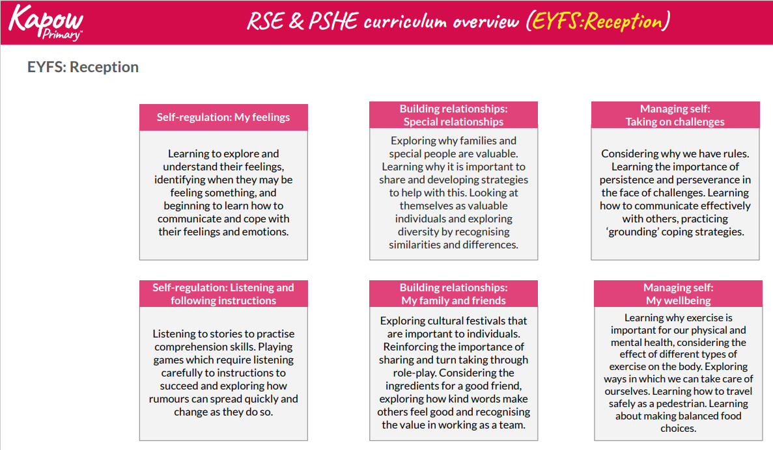
Appendix 2: Curriculum overview, by year group

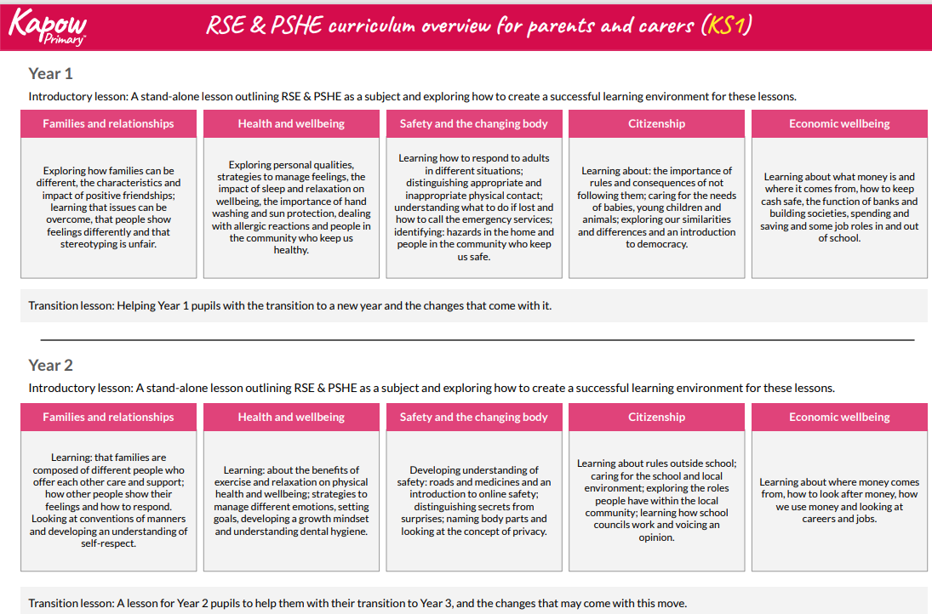
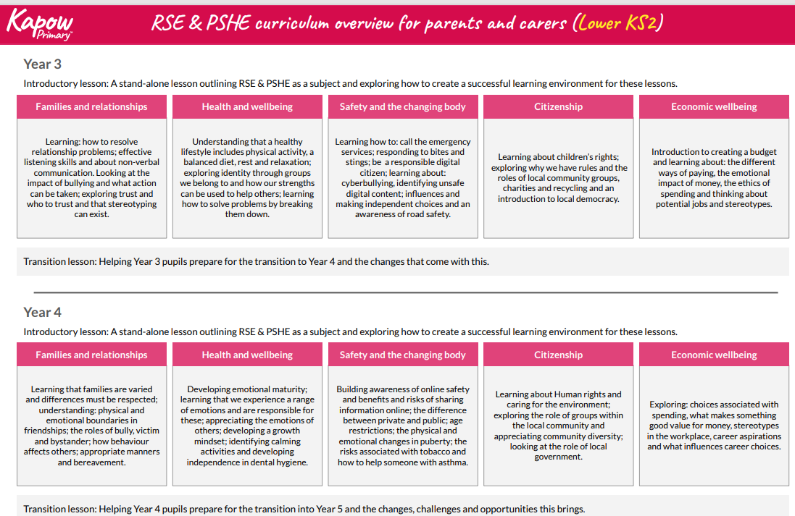
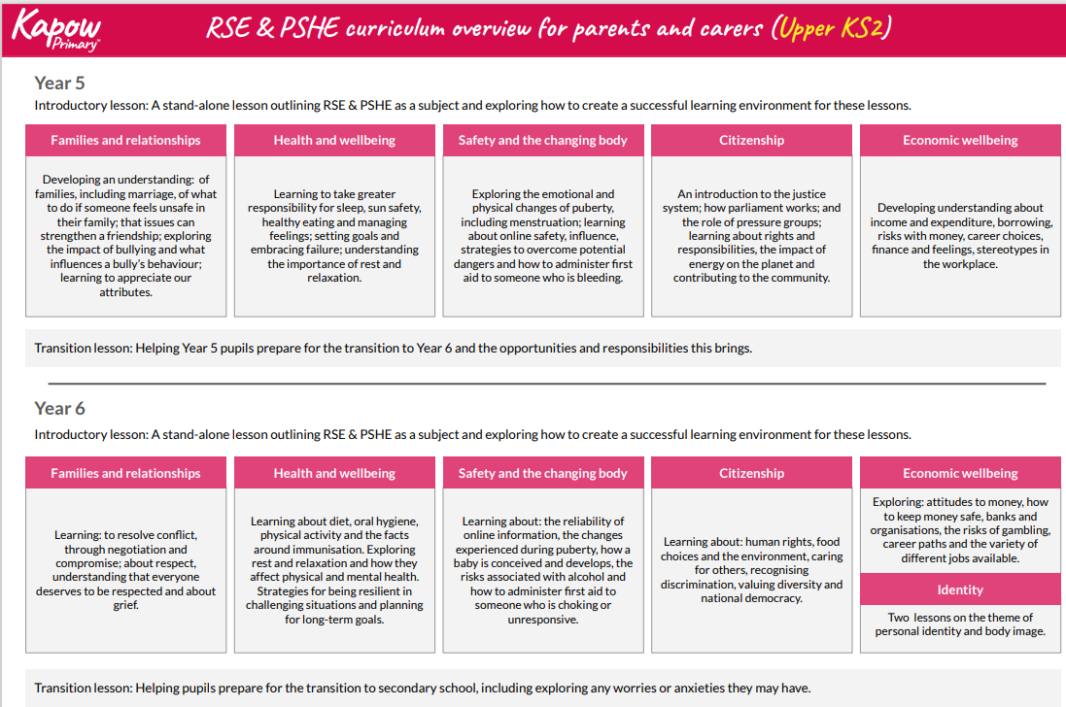

Appendix 3: Parent form for withdrawal from sex education within Relationships and Health Education.

TO BE COMPLETED BY PARENTS
Name of child |  | Class
Name of parent/carer |  | Date
Reason for withdrawing from sex education within Relationships and Health Education
Any other information you would like the school to consider
Parent signature

TO BE COMPLETED BY THE SCHOOL
Agreed actions from discussion with parents

