CTPS Clubs Autumn 2025

 | Club |  |  |  | Staff | Age Range
 | Monday
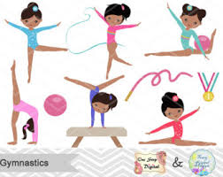 | Gymnastics  Year 1 & Year 2 |  | Gymnastics training will provide children with the necessary skills to be able to be involved with competitions at a level that suits the individual. The sport promotes discipline and lends itself to every other sport through an enjoyable experience that will improve learning across the board and lead to a life-long healthy lifestyle. |  | Mrs. Davis-Eyre | Y1-2
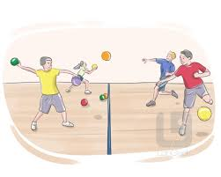 | Dodgeball |  | A team sport where players try to eliminate opponents by hitting them with a thrown ball while dodging incoming balls themselves. |  | Miss Rosenblatt  (Sport’s Coach) | Y3-6
 | Tuesday
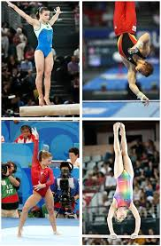 | Gymnastics  Year 3 - Year 6 |  | Gymnastics training will provide children with the necessary skills to be able to be involved with competitions at a level that suits the individual. The sport promotes discipline and lends itself to every other sport through an enjoyable experience that will improve learning across the board and lead to a life-long healthy lifestyle. |  | Miss Davis-Eyre | Y3-6
 | Lego |  | Join our club to build amazing Lego creations. |  | Miss Baker | Y3-6
 | Arts & Crafts |  | Be a part of some creative and fun art activities including bookmark making, collages and more! |  | Miss Jones | Y3-6
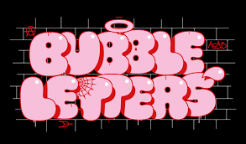 | The Art of Bubble Writing |  | Enhance your creativity and artistic technique, by learning the art of bubble writing. |  | Mx Maynard | Y5-6
 | Dodgeball |  | A team sport where players try to eliminate opponents by hitting them with a thrown ball while dodging incoming balls themselves. |  | Miss Rosenblatt  (Sport’s Coach) | Y1 & Y2
 | Wednesday
 | Target Practice |  | Learn the skills of shooting at a designated target. Improve accuracy, and precision. |  | Miss Rosenblatt  (Sport’s Coach) | Y3-6
 |  | Thursday
 |  | Football |  | Learn football skills and take part in football matches. | Mr.  Howard  (Sport’s coach) | Y3-6
 |  | Choir |  | Join our group of singers and learn new songs. Develop your vocal and musical skills in a fun and enjoyable way. | Miss  Goldsmith | Y3-6
 |  | Film Club |  | Come and enjoy an exciting movie with your friends. | Mrs Pira | Y3-6
 |  | Friday
 |  | Football |  | Learn football skills and take part in football matches. | Mr.  Howard  (Sport’s Coach) | Y1 & Y2

